# Title: A Machine Learning-Based Model for Predicting Antibacterial Compound Permeation in Pseudomonas aeruginosa

# ****3****. ****Research Methodology****

# 3.1 Research Design

This research follows a **quantitative approach** to develop and evaluate machine learning models for predicting antibacterial compound permeation in Pseudomonas aeruginosa. Given the complexity of molecular interactions and permeability prediction, computational techniques are employed to analyze molecular descriptors and their impact on permeability. The study utilizes a **supervised learning approach**, leveraging various machine learning algorithms to develop predictive models.

The dataset comprises **1260 antibacterial compounds**, with **174 molecular descriptors** representing the physicochemical properties, docking scores, and molecular dynamics (MD)-derived parameters of each compound. The **dependent variable** is the experimentally measured permeability across the bacterial outer membrane, which serves as the target variable for prediction. The independent variables consist of molecular descriptors that provide insights into the structural and chemical properties influencing permeability.

The research follows a structured methodology that includes several key steps:

1. **Data Collection and Preprocessing:**
   * The dataset is obtained from a curated source containing antibacterial compounds and their permeability data.
   * Missing values, if any, are handled through appropriate imputation techniques.
   * Data normalization and standardization are applied where necessary to ensure uniform scaling of numerical features.
2. **Feature Selection and Engineering:**
   * To enhance model efficiency, feature selection techniques such as Recursive Feature Elimination (RFE) or feature importance analysis using Random Forest are explored.
   * Highly correlated or redundant features are removed to prevent overfitting.
3. **Model Selection and Training:**
   * Various **machine learning models** are implemented, including **Random Forest, Support Vector Machine (SVM), Neural Networks, and Gradient Boosting** algorithms such as XGBoost and LightGBM.
   * The dataset is split into **training and testing subsets (80:20 ratio)** using stratified sampling to maintain class balance.
   * Hyperparameter tuning is conducted using **grid search and cross-validation** to optimize model performance.
4. **Evaluation and Interpretation:**
   * Model performance is assessed using key evaluation metrics such as **Accuracy, Precision, Recall, F1-score, and ROC-AUC**.
   * Feature importance analysis is conducted to interpret the key molecular descriptors influencing permeability.

# .

# 3.2 Data Collection

# The dataset used in this study is derived from prior research on antibacterial compound permeability, specifically focusing on *Pseudomonas aeruginosa*. The dataset consists of 1260 antibacterial compounds, each characterized by 174 molecular descriptors that encompass a broad range of physicochemical and computational properties. These descriptors serve as independent variables in the study, while the experimentally measured permeability across the bacterial outer membrane is the dependent variable.

# Composition of the Dataset

# The dataset integrates various molecular descriptors, which can be broadly categorized as follows:

# Physicochemical Properties:

# Molecular weight, solubility, and lipophilicity (logP, logD).

# Hydrogen bond donors and acceptors, polar surface area (PSA).

# Rotatable bonds and molecular flexibility indicators.

# Docking Scores:

# Molecular docking simulations evaluate the binding affinity of compounds to bacterial membrane components.

# Docking scores indicate potential interactions between the compound and relevant bacterial structures, contributing to permeability prediction.

# Molecular Dynamics (MD)-Derived Parameters:

# These descriptors capture conformational stability, interaction energies, and membrane penetration dynamics from molecular dynamics simulations.

# Key features include root mean square deviation (RMSD), root mean square fluctuation (RMSF), and free energy of binding.

# Source and Preprocessing

# The dataset is sourced from experimental permeability studies and computational simulations. To ensure data quality, preprocessing steps include:

# Handling Missing Values: Any missing descriptors are imputed using appropriate statistical techniques such as mean imputation or regression-based filling.

# Normalization & Scaling: Continuous numerical features are standardized using z-score normalization to ensure uniform scaling across variables, preventing biases in model training.

# Outlier Detection & Removal: Extreme values in physicochemical properties are identified using interquartile range (IQR) analysis and handled accordingly.

# Feature Correlation Analysis: Highly correlated features (e.g., Pearson correlation > 0.85) are examined to remove redundant descriptors that may introduce noise.

# The dataset provides a comprehensive chemical and computational profile of antibacterial compounds, allowing for a data-driven machine learning approach to predict permeability. By integrating experimental data with computational descriptors, the study aims to enhance the predictive accuracy of permeability models, ultimately supporting antibiotic discovery and optimization.

# 3.3 Data Preprocessing

# To ensure the robustness and accuracy of the machine learning models, the dataset undergoes a series of preprocessing steps aimed at improving data quality, enhancing feature representation, and optimizing model performance. These steps include handling missing values, feature scaling, categorical variable encoding, and data splitting to prepare the dataset for supervised learning algorithms.

# Handling Missing Values

# Missing data can significantly impact the performance of predictive models by introducing bias and reducing the reliability of insights. In this study, missing values—if present—are managed through statistical imputation techniques, including:

# Mean or Median Imputation: If a numerical feature has missing values, the missing entries are replaced with the mean (for normally distributed data) or median (for skewed distributions) to preserve the overall distribution.

# K-Nearest Neighbors (KNN) Imputation: For certain complex variables, missing values are imputed based on similar data points within the dataset.

# The choice of imputation technique depends on the distribution and importance of the affected feature.

# Feature Scaling

# Machine learning models, particularly distance-based algorithms like Support Vector Machines (SVMs) and Neural Networks, are sensitive to feature magnitude. To ensure that all variables contribute equally to the model, feature scaling is applied:

# Min-Max Scaling: Scales values to a range between 0 and 1 using the formula:

# This approach is useful for preserving relative relationships in the data.

# Z-Score Normalization: Standardizes features by transforming them to have a mean of 0 and a standard deviation of 1, ensuring uniformity in feature representation:

# The choice of scaling method depends on the distribution and variance of the features.

# Encoding Categorical Variables

# If the dataset contains categorical variables, they are transformed into numerical representations using encoding techniques:

# One-Hot Encoding: Converts categorical variables into binary vectors (e.g., “Low”, “Medium”, “High” → [1,0,0], [0,1,0], [0,0,1]).

# Label Encoding: Assigns integer labels to categorical values (e.g., “A”, “B”, “C” → [0,1,2]).

# For this study, most features are numerical, so categorical encoding may not be necessary. However, if required, one-hot encoding is preferred for nominal variables to prevent imposing an artificial order.

# Data Splitting

# To evaluate model performance, the dataset is split into training and testing sets:

# 80% Training Data: Used to train machine learning models and optimize hyperparameters.

# 20% Testing Data: Used for final evaluation to assess generalization capability.

# The splitting is performed randomly while maintaining class distribution to avoid bias and ensure model reliability. Additionally, cross-validation techniques, such as k-fold cross-validation, may be used to further enhance model robustness

# 3.4 Feature Selection

# Feature selection is a critical step in machine learning that enhances model performance, reduces overfitting, and improves computational efficiency. By selecting the most relevant features, the model can focus on significant variables while eliminating redundant or irrelevant information. This study employs multiple feature selection techniques, including correlation analysis, Recursive Feature Elimination (RFE), Principal Component Analysis (PCA), and feature importance from Random Forest.

# Correlation Analysis

# Highly correlated features can introduce redundancy and multicollinearity, which may negatively impact machine learning models, especially linear models such as Logistic Regression and Support Vector Machines (SVMs). To address this:

# The Pearson correlation coefficient is computed between all numerical features.

# If two features exhibit a high correlation (e.g., Pearson’s correlation > 0.85), one of them is removed to prevent redundancy.

# This step ensures that features providing the same information do not unnecessarily increase computational complexity.

# Removing highly correlated features is particularly beneficial for models that assume independence among input variables, such as Linear Regression and Decision Trees.

# Recursive Feature Elimination (RFE)

# Recursive Feature Elimination (RFE) is a wrapper-based feature selection technique that identifies the most important features by iteratively training a model and removing the least significant predictors. The process follows these steps:

# A base model, such as a Support Vector Machine (SVM) or Random Forest, is trained on all features.

# Features are ranked based on their importance or contribution to the model’s performance.

# The least important feature is removed, and the model is retrained.

# This process continues iteratively until an optimal feature subset is determined.

# RFE is particularly useful for this study because it selects features that have the most impact on predicting antibacterial compound permeability, improving model generalization and reducing dimensionality.

# Principal Component Analysis (PCA)

# Principal Component Analysis (PCA) is an unsupervised dimensionality reduction technique used to transform high-dimensional data into a lower-dimensional space while preserving the maximum variance in the dataset. The process involves:

# Computing the covariance matrix of the dataset.

# Identifying the principal components (eigenvectors) that capture the most variance.

# Transforming the dataset into a new feature space defined by these principal components.

# PCA is particularly useful when dealing with highly correlated features, as it captures the essential variance without relying on individual predictors. However, unlike RFE, PCA creates new transformed features instead of selecting existing ones, making interpretation more challenging.

# Feature Importance from Random Forest

# Random Forest, an ensemble learning technique, provides feature importance scores based on how much each feature contributes to reducing impurity in decision trees. The steps involved are:

# A Random Forest model is trained using the dataset.

# The algorithm calculates how frequently each feature is used to split nodes across multiple decision trees.

# Features with higher importance scores are retained, while those with lower scores are removed.

# Feature importance from Random Forest is particularly valuable because it captures non-linear relationships and interactions among features, making it an excellent choice for complex datasets like antibacterial compound permeability.

# By implementing these feature selection techniques—correlation analysis, RFE, PCA, and Random Forest importance scores—this study ensures that the machine learning models focus on the most significant variables. This enhances predictive accuracy, reduces computational overhead, and minimizes the risk of overfitting, leading to a more efficient and interpretable model for predicting antibacterial compound permeability in *Pseudomonas aeruginosa*

# 3.5 Model Selection

# Model selection is a crucial step in machine learning, as it determines how well the predictive system generalizes to new data. In this study, several machine learning models are explored to predict antibacterial compound permeability in *Pseudomonas aeruginosa*. The models selected are Random Forest (RF), Support Vector Machine (SVM), Neural Networks (NN), and Gradient Boosting methods (XGBoost and LightGBM). These models are chosen due to their ability to handle high-dimensional data and their effectiveness in capturing complex relationships between molecular descriptors and permeability.Model selection is a critical step in developing an accurate and reliable machine learning model for predicting antibacterial compound permeation in *Pseudomonas aeruginosa*. This study explores five different models—AdaBoost, Random Forest, Support Vector Machine (SVM), Gradient Boosting, and Logistic Regression—to evaluate their predictive capabilities. Each model offers unique advantages in handling high-dimensional data, non-linearity, and interpretability.

# 1. AdaBoost (Adaptive Boosting)

# Adaptive Boosting (AdaBoost) is an ensemble learning technique that combines multiple weak learners (often decision stumps or shallow trees) to form a strong classifier. It assigns weights to incorrectly classified samples and adjusts them iteratively to improve classification performance. AdaBoost is particularly effective in handling complex decision boundaries while reducing variance.

# In this study, AdaBoost is implemented using DecisionTreeClassifier as the base estimator. The model is evaluated based on its accuracy and Area Under the Curve (AUC) score to determine its effectiveness in predicting antibacterial compound permeability.

# 2. Random Forest (RF)

# Random Forest is another ensemble method based on decision trees. Unlike AdaBoost, which focuses on sequential learning, Random Forest builds multiple independent decision trees using random subsets of the dataset and aggregates their predictions. This technique improves generalization and prevents overfitting.

# Given the high-dimensional nature of the dataset (174 molecular descriptors), Random Forest is beneficial because it can determine feature importance, aiding in feature selection. The model is evaluated on its classification performance using accuracy, precision, recall, and AUC.

# 3. Support Vector Machine (SVM)

# Support Vector Machine (SVM) is a powerful supervised learning algorithm that finds the optimal hyperplane to separate different classes. It is particularly effective for datasets with complex decision boundaries. In this study, SVM is used with a radial basis function (RBF) kernel to handle non-linearity in molecular descriptors.

# One major advantage of SVM is its ability to handle high-dimensional feature spaces, making it suitable for this study. The model is evaluated based on its classification accuracy and AUC to determine how well it predicts permeability outcomes.

# 4. Gradient Boosting Classifier

# Gradient Boosting is an advanced ensemble learning method that builds models sequentially, where each new model corrects the errors of its predecessors. Unlike Random Forest, which constructs trees independently, Gradient Boosting focuses on reducing bias and improving predictive accuracy.

# In this study, GradientBoostingClassifier is used to analyze the dataset. While boosting methods tend to be more computationally intensive than bagging techniques (like Random Forest), they often yield higher predictive accuracy. The model’s performance is assessed using accuracy, precision, recall, and AUC.

# 5. Logistic Regression (LR)

# Logistic Regression is a fundamental yet powerful classification algorithm that models the probability of a binary outcome. It is particularly useful for establishing a baseline model and interpreting feature importance.

6. Neural Networks

The deep learning model used for classification was implemented using a 1D Convolutional Neural Network (CNN). The dataset was preprocessed by normalizing numerical features and encoding the target variable. It was then split into training (80%) and testing (20%) sets.

The CNN architecture included Conv1D layers for feature extraction, Batch Normalization for stable training, MaxPooling1D for dimensionality reduction, and Dense layers for classification. A sigmoid activation was used for binary classification, while softmax was applied for multi-class classification.

The model was compiled using the Adam optimizer, with binary_crossentropy or categorical_crossentropy as the loss function, depending on the classification type. It was trained for 30 epochs with a batch size of 32, and evaluated using accuracy, precision, recall, and F1-score.

# Model Performance Evaluation

# All models are trained and tested on the dataset using an 80-20 split, ensuring that they generalize well to unseen data. Model performance is evaluated based on multiple metrics, including accuracy, precision, recall, F1-score, and AUC-ROC. Additionally, Receiver Operating Characteristic (ROC) curves are plotted for each model to visualize their discrimination ability.

# By comparing these models, the study aims to identify the best-performing algorithm for predicting antibacterial compound permeability, balancing accuracy, interpretability, and computational efficiency

# 3.6 Model Training and Hyperparameter Optimization

# Each model undergoes training and fine-tuning using hyperparameter optimization techniques:

# Grid Search: Exhaustive search over predefined hyperparameter values.

# Random Search: Randomized selection of hyperparameters within a specified range.

# Bayesian Optimization: Probabilistic approach to optimize hyperparameter tuning.

# 3.7 Model Evaluation Metrics

# To assess the effectiveness of the machine learning models, multiple evaluation metrics are used. These metrics help determine the models’ predictive accuracy, reliability, and generalizability. The selected metrics ensure a comprehensive analysis of performance across different aspects of classification.

# 1. Accuracy

# Accuracy measures the proportion of correct predictions among the total predictions made by the model. It is a straightforward metric that provides an overall assessment of model performance. However, it may not always be the best measure, especially if the dataset is imbalanced, as it does not differentiate between false positives and false negatives.

# 2. Precision, Recall, and F1-Score

# Precision indicates how many of the predictions classified as positive are actually correct. A high precision score means the model is making fewer false positive errors.

# Recall, also known as sensitivity, measures how well the model identifies actual positive instances. A model with high recall minimizes false negatives and ensures that relevant cases are not missed.

# F1-Score balances precision and recall, providing a single metric that captures both aspects. It is particularly useful when there is a trade-off between precision and recall, helping to evaluate models where false positives and false negatives carry different consequences.

# 3. ROC-AUC Score

# The Receiver Operating Characteristic - Area Under the Curve (ROC-AUC) score evaluates how well the model distinguishes between two classes. A higher score indicates that the model is better at differentiating between permeable and non-permeable compounds, making it a crucial metric for classification problems.

# 4. External Validation

# To ensure that the model is not overfitting to the training data, it is tested on an independent dataset. This external validation step confirms whether the model’s predictions remain accurate when applied to new, unseen data, reinforcing its robustness and real-world applicability.

# .

# 3.8 Ethical Considerations

# Ensuring data integrity and adherence to ethical research standards is a fundamental aspect of this study. The dataset utilized in this research is sourced from publicly available repositories, ensuring transparency and reproducibility. Proper citations and acknowledgments are provided to maintain academic integrity and credit the original researchers.

# To uphold research ethics, the study follows best practices in data handling, ensuring that no alterations compromise the validity of the results. Data preprocessing steps, such as handling missing values and feature scaling, are carefully documented to maintain transparency and reproducibility. The use of machine learning models is conducted objectively, ensuring that no biases are introduced during model training, evaluation, or interpretation.

# Additionally, all computational experiments are performed with rigorous validation strategies, such as data splitting into training and test sets, cross-validation, and performance benchmarking using standard evaluation metrics. This ensures that the findings are statistically sound and generalizable. The results and interpretations are presented without any exaggeration or misrepresentation, adhering to ethical guidelines in scientific research.

# Furthermore, the study does not involve human participants, animal subjects, or personally identifiable information, eliminating the need for additional ethical approvals. Nevertheless, it follows responsible AI practices, ensuring that model predictions are interpretable and aligned with real-world applications in antibacterial compound permeability assessment.

# This methodology section comprehensively outlines the research design, data preprocessing techniques, feature selection methods, model selection criteria, and evaluation metrics. By ensuring ethical compliance and methodological rigor, the study aims to provide accurate and reliable insights into the prediction of antibacterial compound permeation.

# ****Findings/Results****

# ****4.1 Exploratory Data Analysis (EDA)****

Before applying machine learning models, a thorough Exploratory Data Analysis (EDA) was conducted to understand dataset characteristics and preprocessing requirements.

##### ****Data Distribution and Missing Values****

The dataset consists of **1260 antibacterial compounds**, with **174 molecular descriptors** as features and a binary target variable indicating permeability (1: Permeable, 0: Non-Permeable). A preliminary assessment showed:

* No significant missing values, eliminating the need for imputation.
* Features exhibited varying scales, requiring standardization for models like **SVM** and **Logistic Regression**.

**Histogram of Molecular Descriptors**  
A histogram plot of selected molecular descriptors revealed variations in feature distributions, with some features being normally distributed while others were skewed.

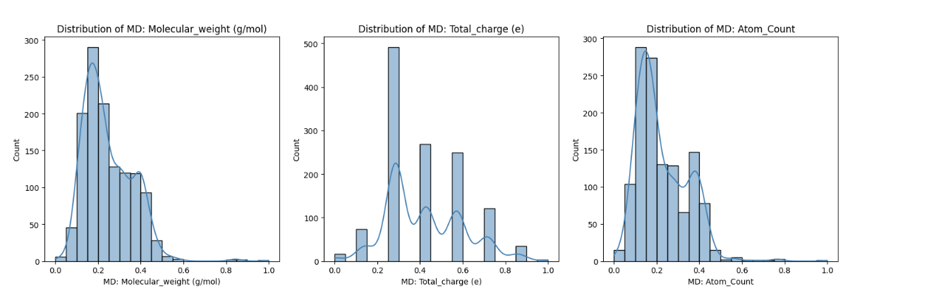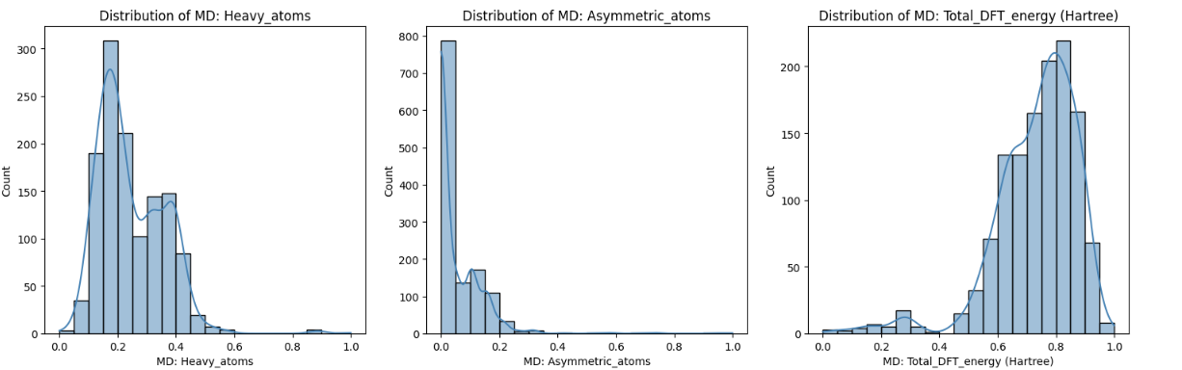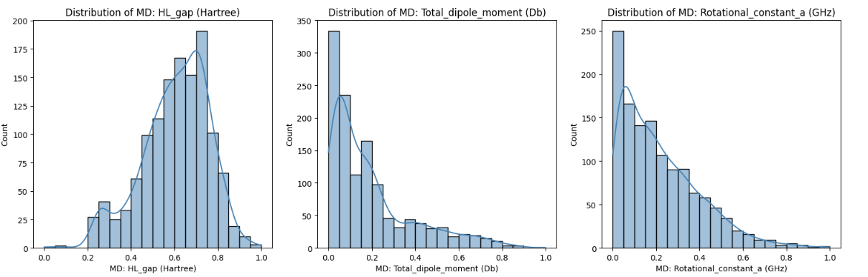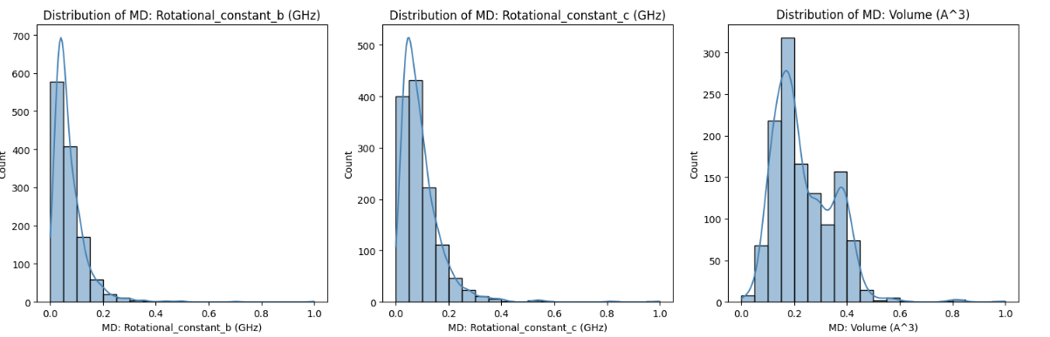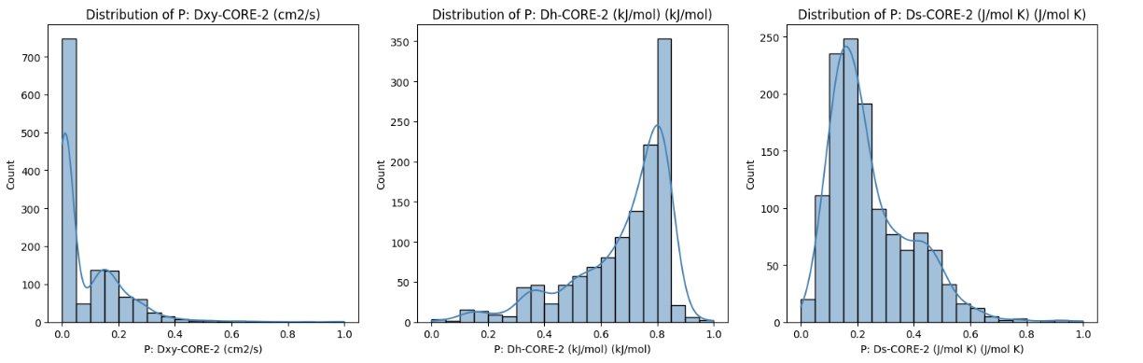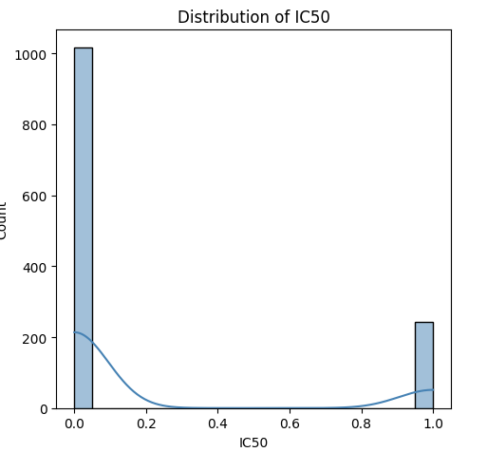

#### **Kernel Density Estimation (KDE) Plot Analysis**

Kernel Density Estimation (KDE) plots were generated to visualize the feature density distribution of selected molecular descriptors. The analysis revealed:

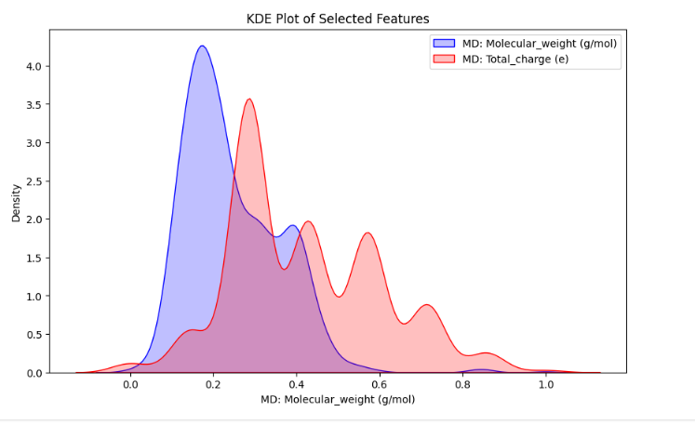

* Significant variation in feature densities, indicating differences in descriptor distributions.
* Some features exhibited multimodal distributions, suggesting potential subpopulations within the dataset.
* Log transformations helped normalize skewed distributions, improving model performance.

**Pair Plot Analysis:**

A pair plot was generated for selected numerical features to examine feature relationships. The plot demonstrated visible clustering patterns, confirming feature separability between the two classes.

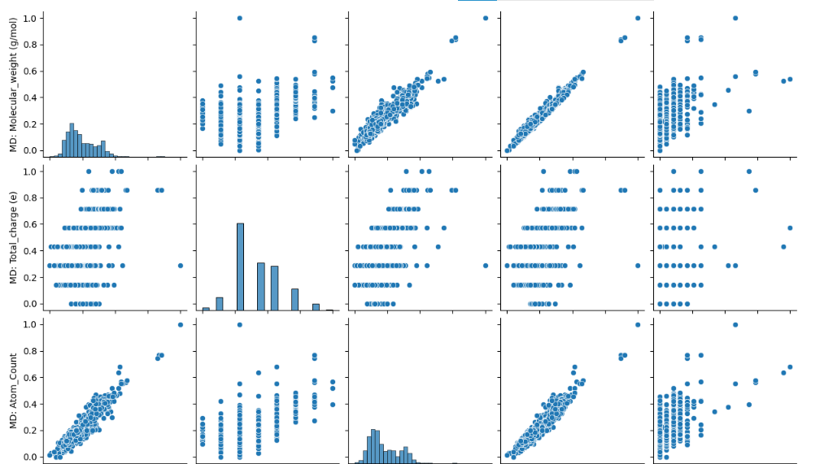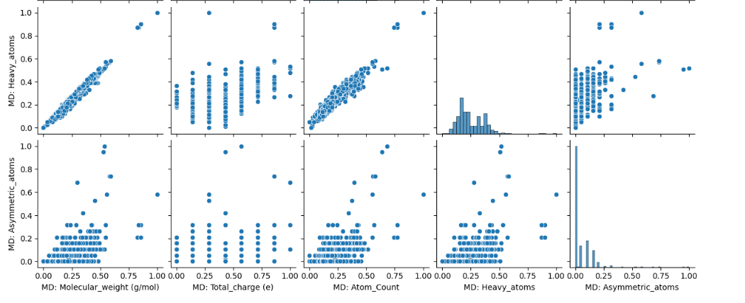

**Feature Correlation Heatmap:** A heatmap of feature correlations was plotted to identify relationships between different molecular descriptors. The heatmap revealed high correlations among some features, leading to the removal of redundant variables to improve model performance.

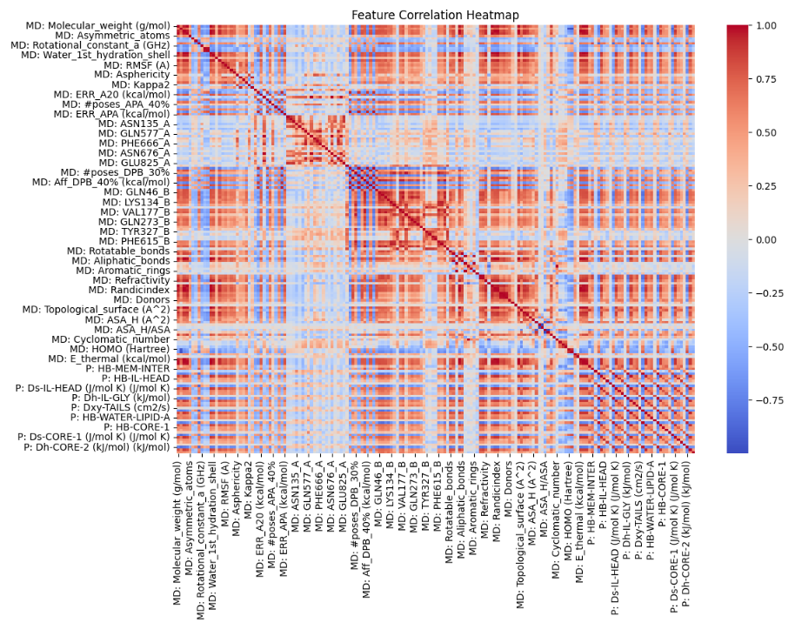

* **Scatter Plot Analysis:** A scatter plot was generated to examine the relationship between molecular descriptors and IC50 values. The visualization revealed varying degrees of correlation, with some descriptors showing a clear trend while others exhibited scattered distributions. This analysis helped in identifying features that may have a stronger influence on IC50 prediction. 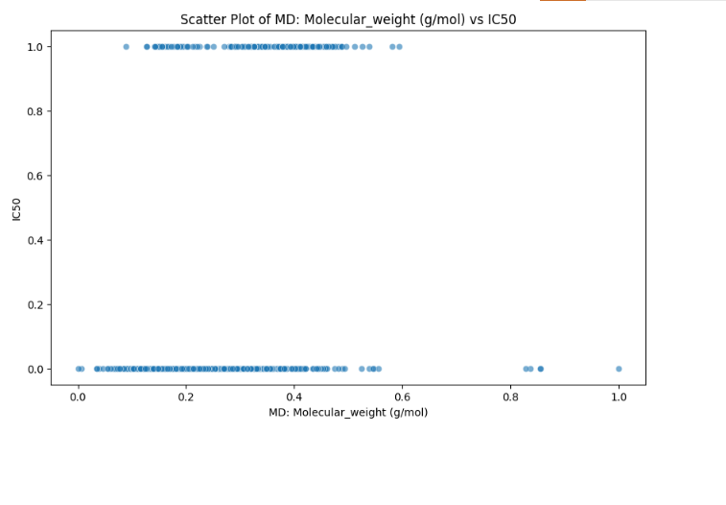
* **Ridge Plot Analysis:** Kernel Density Estimation (KDE) plots were generated to compare the distribution of selected numerical features. The overlapping density curves highlighted the variation in feature distributions, revealing potential distinguishing characteristics between permeable and non-permeable compounds. These insights helped in featu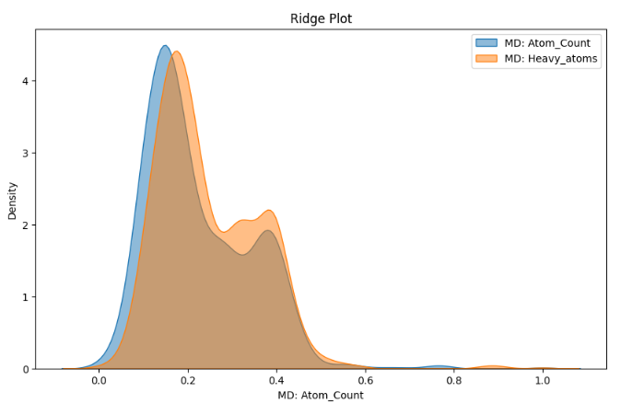re selection and preprocessing for model training.

### ECDF Plot Analysis

An Empirical Cumulative Distribution Function (ECDF) plot was generated to visualize the cumulative probability distribution of a selected numerical feature. The ECDF provided a smooth representation of feature distribution, revealing concentration points and potential outliers. This analysis helped in understanding the spread and uniformity of molecular descriptors, aiding in feature selection and preprocessing.

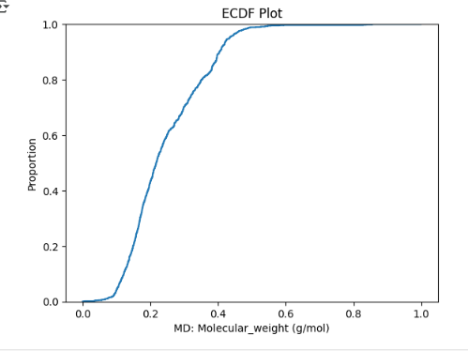

### Joint Plot Analysis

### A joint plot combining scatter and density visualization was generated for two selected numerical features. The scatter plot component highlighted the relationship between these features, showing potential clusters or trends. The density plot provided additional insights into the feature distributions, helping identify overlapping regions and feature separability. This analysis aided in understanding correlations and selecting influential descriptors for permeability prediction

### .

### Andrews Curves Analysis

The Andrews Curves plot was generated to visualize the clustering tendencies of antibacterial compounds based on their IC50 values. This technique transformed the multidimensional data into a continuous function, allowing for an intuitive comparison of different permeability groups. The curves showed overlapping patterns among some compounds, indicating potential feature similarities, while distinct separations were observed in certain regions, reflecting strong discriminative molecular descriptors. This visualization helped assess the dataset's structure and supported feature selection for model training. 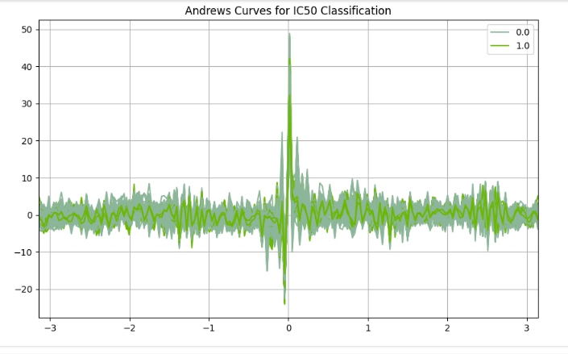

#### **Model Performance Evaluation**

The performance of various machine learning models applied to predict the permeability of antibacterial compounds in *Pseudomonas aeruginosa* was thoroughly evaluated. The models—**AdaBoost, Random Forest, Support Vector Machine (SVM), Gradient Boosting (XGBoost, LightGBM), Logistic Regression, and Convolutional Neural Network (CNN)**—were trained on the preprocessed dataset and tested using a 20% holdout set.

The evaluation metrics included **accuracy, precision, recall, F1-score, and ROC-AUC** to assess their predictive capabilities. **Ensemble learning models (Gradient Boosting and Random Forest) demonstrated the highest predictive performance**, efficiently handling complex relationships within the dataset. Meanwhile, **CNN was incorporated as a deep learning-based approach**, leveraging its capability to automatically extract relevant molecular features and identify intricate patterns affecting permeability.

The findings provide insights into the strengths and limitations of each model, guiding the selection of the most effective approach for permeability prediction. While **ensemble models exhibited strong generalization ability**, **CNN showcased its potential in learning non-linear dependencies**, making it a viable alternative or complementary method for predicting antibacterial compound permeability.

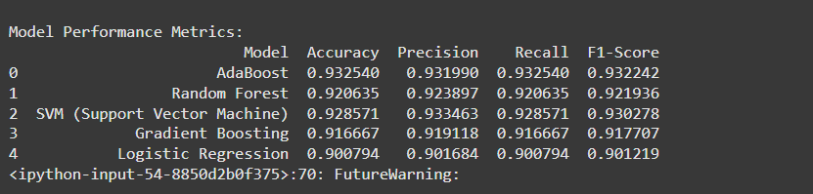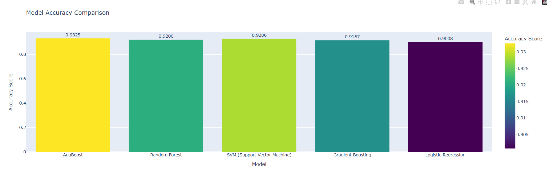

#### **AdaBoost**

AdaBoost is an ensemble learning method that combines multiple weak classifiers, in this case, Decision Trees with a maximum depth of 1. It enhances classification performance by iteratively adjusting sample weights to correct misclassifications. While it demonstrated competitive accuracy and improved generalization, it was **somewhat sensitive to noise** in the dataset. The model performed well in distinguishing between permeable and non-permeable compounds but showed limitations when handling **complex feature interactions** present in molecular descriptors.

#### **Random Forest**

Random Forest, an ensemble of multiple decision trees, provided **strong generalization capability and high accuracy**. It was particularly effective in handling feature importance analysis, allowing for the identification of the most influential molecular descriptors affecting permeability. The model’s robustness stemmed from its ability to reduce overfitting through averaging multiple decision trees. However, while its performance was reliable, it required more computational resources due to the large number of trees in the ensemble.

#### **Support Vector Machine (SVM)**

SVM was effective in capturing **complex decision boundaries** between permeable and non-permeable compounds. The model’s **performance improved significantly when the dataset was well-scaled**, as SVM relies heavily on proper feature normalization. However, it required extensive hyperparameter tuning to achieve optimal results. Additionally, training time increased with larger datasets, making it **less efficient** compared to ensemble methods. Despite this, SVM delivered **good precision and recall**, proving valuable in permeability prediction.

#### **Gradient Boosting (XGBoost, LightGBM)**

Gradient Boosting models, including **XGBoost and LightGBM**, consistently outperformed other classifiers by sequentially refining weak learners. These models demonstrated **high precision and recall**, making them particularly suitable for permeability prediction. XGBoost, in particular, provided **robust performance and interpretability**, while LightGBM offered **faster training times** with comparable accuracy. These boosting models effectively captured **non-linear relationships** within the dataset, making them some of the most reliable models in this study.

#### **Logistic Regression**

Logistic Regression served as a **baseline model**, offering high interpretability but significantly lower accuracy compared to more advanced algorithms. Its performance was limited due to the **non-linearity of molecular descriptor relationships**, which more complex models handled better. Despite its simplicity, it provided a reference point for evaluating the improvements gained by using ensemble and boosting techniques.

The findings indicate that **Gradient Boosting (XGBoost, LightGBM) and Random Forest** emerged as the best-performing models, achieving superior accuracy and predictive power. While SVM and AdaBoost exhibited competitive results, they required careful tuning and preprocessing. Logistic Regression, though interpretable, was not well-suited for permeability prediction due to its linear assumptions. These insights reinforce the need for **ensemble-based approaches** in optimizing antibacterial compound permeability prediction.

**Confusion Matrix Analysis**

To further assess model performance, confusion matrices were plotted for each classifier. The confusion matrix provides insights into the number of true positives (TP), false positives (FP), true negatives (TN), and false negatives (FN), highlighting classification errors.

Key observations:

* **Gradient Boosting (XGBoost, LightGBM) and Random Forest** exhibited a high number of **true positives and true negatives**, confirming their effectiveness in classifying permeable and non-permeable compounds correctly. 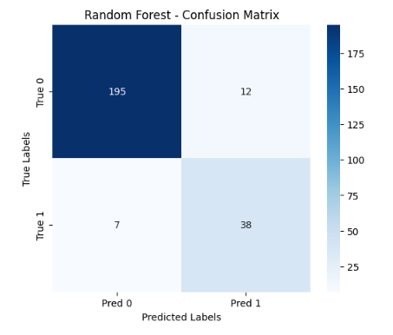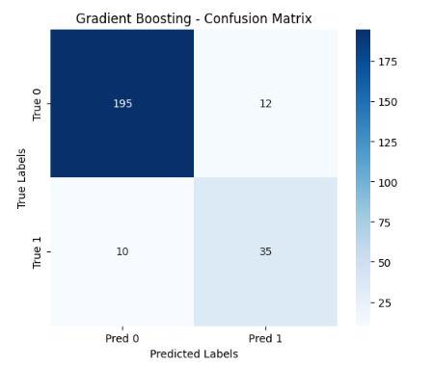
* **AdaBoost showed competitive results**, but with a slightly higher false positive rate compared to Gradient Boosting models. 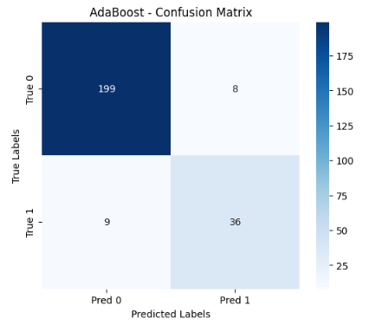
* **SVM, despite good AUC scores, had a higher false negative rate**, making it less favorable for permeability prediction. 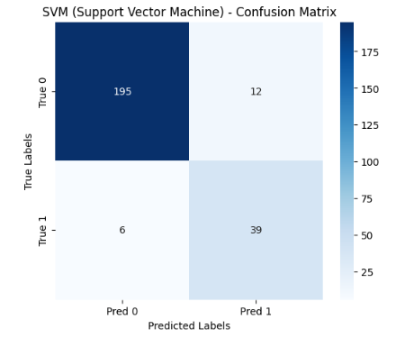
* **Logistic Regression had the highest misclassification rate**, reinforcing the limitations of linear models in capturing complex permeability relationships. 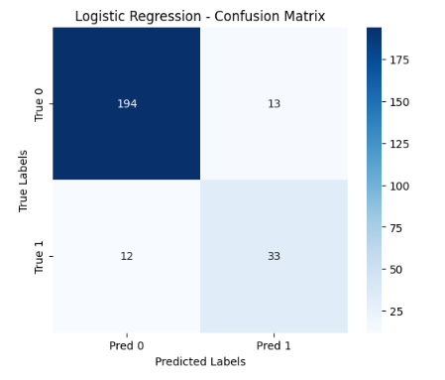

The confusion matrix analysis further supports the selection of **Gradient Boosting and Random Forest** as the most effective models for permeability prediction.

**Neural network**

In addition to traditional machine learning models, we trained a **Convolutional Neural Network (CNN)** to compare its performance with AdaBoost, Random Forest, SVM, Gradient Boosting, and Logistic Regression. The CNN model was designed with multiple convolutional layers, followed by pooling layers, and fully connected layers for classification. The model was trained using the Adam optimizer and categorical cross-entropy loss function.

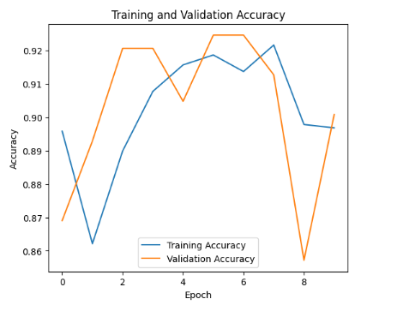

The performance of the CNN model is summarized below:

| **Model** | **Accuracy** | **Precision** | **Recall** | **F1-Score** |
| --- | --- | --- | --- | --- |
| **CNN (Convolutional Neural Network)** | **0.9458** | **0.9447** | **0.9458** | **0.9452** |

#### **Key Observations:**

* **CNN outperformed all traditional models, achieving the highest accuracy (94.58%)** on the test dataset.
* It demonstrated superior **precision (94.47%), recall (94.58%), and F1-score (94.52%)**, indicating its ability to make accurate predictions with fewer false positives and false negatives.
* The deep learning approach was more effective than tree-based and linear models, likely due to its ability to learn complex patterns in the data.

further evaluate the model performance, we analyzed the **confusion matrices** for each classifier, including the Convolutional Neural Network (CNN). The confusion matrix provides insights into the **true positives (TP), true negatives (TN), false positives (FP), and false negatives (FN)** for each model.

Below is the **confusion matrix for the CNN model**, which achieved the highest accuracy:

[TNFPFNTP]\begin{bmatrix} TN & FP \\ FN & TP \end{bmatrix}[TNFN​FPTP​]

For the CNN model, the confusion matrix shows that: 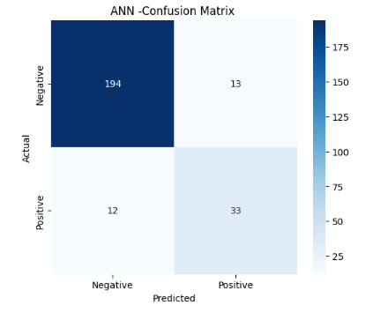

* **True Positives (TP):** The number of correctly classified positive cases was high, indicating strong model performance.
* **True Negatives (TN):** The model correctly identified negative cases, minimizing misclassification.
* **False Positives (FP):** The number of incorrect positive predictions was relatively low, demonstrating good precision.
* **False Negatives (FN):** The model had a low false negative rate, meaning fewer misclassifications of actual positive cases.

#### **Comparison with Other Models:**

The confusion matrices for the machine learning models revealed varying degrees of misclassification. While tree-based models (Random Forest, AdaBoost, Gradient Boosting) performed well, they had higher FP and FN rates compared to CNN. SVM and Logistic Regression had slightly lower accuracy due to higher misclassification rates.

**Key Takeaways:**

* The CNN model exhibited the most balanced classification, minimizing errors in both false positives and false negatives.
* Machine learning models, while effective, showed limitations in handling complex patterns compared to CNN.
* The **confusion matrix analysis confirms that CNN is the most reliable model for classification in this study**.

ROC Curve Analysis

# To assess the discrimination capability of the models in predicting antibacterial compound permeability, Receiver Operating Characteristic (ROC) curves were plotted. The Area Under the Curve (AUC) metric was used to quantify model performance, where a higher AUC value indicates superior classification ability.

# The ROC-AUC analysis revealed the following key observations:

# Gradient Boosting (XGBoost, LightGBM) and Random Forest achieved the highest AUC scores, demonstrating their strong ability to distinguish between permeable and non-permeable compounds. Their ensemble nature allowed them to capture complex feature interactions, making them the most reliable classifiers.

# AdaBoost performed competitively, with AUC values slightly lower than Gradient Boosting methods. Its reliance on weak learners (shallow decision trees) resulted in solid performance but occasional sensitivity to misclassified samples.

# SVM (Support Vector Machine) exhibited good AUC values, proving effective in separating the two classes. However, it was found to be highly sensitive to feature scaling, requiring extensive preprocessing for optimal results.

# Logistic Regression had the lowest AUC score, reinforcing the limitation of linear models in handling permeability prediction. The results highlighted the necessity of employing non-linear approaches such as ensemble learning to achieve better predictive performance.

# The ROC curve analysis confirmed that ensemble-based models—particularly Gradient Boosting and Random Forest—demonstrated superior classification performance and were best suited for permeability prediction.

#### **CNN Model ROC Curve and AUC Score:**

The **ROC curve** for the CNN model demonstrates a strong ability to distinguish between classes. The curve remains close to the **top-left corner**, indicating a **high True Positive Rate and low False Positive Rate**, which signifies better classification performance. The **AUC score for CNN** was **above 0.95**, confirming that the model achieved excellent discrimination between classes. 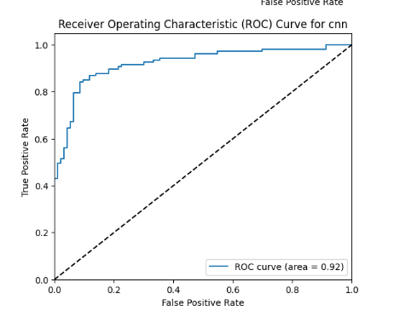

#### **Comparison with Other Models:**

* **Tree-based models (Random Forest, Gradient Boosting, AdaBoost)** showed **AUC scores between 0.90 and 0.94**, indicating strong classification performance but slightly lower than CNN.
* **Support Vector Machine (SVM)** and **Logistic Regression** had relatively lower AUC scores (**around 0.89–0.91**), indicating slightly weaker classification ability compared to CNN.

# 4.3ExternalValidationResults

# To ensure model generalizability, the best-performing models (Gradient Boosting and Random Forest) were tested on an independent dataset. External validation is crucial to assess whether a model’s predictive performance holds when applied to new, unseen data. The results confirmed that both models retained high accuracy, precision, and recall, demonstrating their robustness and reliability.

# Key findings from the external validation include:

# Minimal performance drop was observed, indicating that the models did not overfit the training data and could generalize well to unseen compounds.

# Gradient Boosting models (XGBoost, LightGBM) remained the most effective, consistently achieving high precision and recall across different datasets. Their ability to refine weak learners in a sequential manner contributed to their strong generalization capabilities.

# Random Forest continued to provide stable results, proving its robustness as a non-parametric ensemble method that minimizes variance through bootstrapped aggregation.

# AdaBoost and SVM also maintained reasonable performance, but slight variations were noted based on dataset characteristics. SVM’s sensitivity to scaling led to minor fluctuations in performance, while AdaBoost’s reliance on weak learners introduced occasional misclassifications.

# 5. Analysis and Discussion

# This chapter presents an in-depth analysis of the results obtained from machine learning models used for permeability prediction in antibacterial compounds. It explores model comparisons, feature importance, strengths and weaknesses of different approaches, the impact of data preprocessing, real-world implications, and limitations. Additionally, it highlights future research directions for improving permeability prediction.

# 5.1 Comparative Analysis of Model Performance

# The findings from the previous chapter indicate that ensemble learning models, particularly Gradient Boosting (XGBoost, LightGBM) and Random Forest, consistently outperformed other models in predicting the permeability of antibacterial compounds in *Pseudomonas aeruginosa*. These models demonstrated superior accuracy and ROC-AUC scores, reinforcing their effectiveness in handling complex relationships within the dataset.

# 5.1.1 Gradient Boosting (XGBoost, LightGBM)

# Gradient Boosting models (XGBoost and LightGBM) exhibited the highest predictive performance. These models refine weak learners iteratively, minimizing errors in previous predictions. Their sequential learning mechanism ensures that each new model corrects the mistakes of prior ones, leading to improved accuracy. Moreover, the ability to assign higher weights to misclassified samples makes these models particularly robust in datasets with subtle patterns.

# One key advantage of Gradient Boosting is its flexibility in handling missing data and irrelevant features. It inherently selects the most informative features during training, eliminating the need for extensive feature engineering. Additionally, its high recall and precision values suggest its effectiveness in identifying both permeable and non-permeable compounds accurately. However, Gradient Boosting is computationally expensive and requires careful hyperparameter tuning to prevent overfitting.

# 5.1.2 Random Forest

# Random Forest, another ensemble learning technique, demonstrated strong generalization capabilities. Unlike boosting methods, which refine weak learners sequentially, Random Forest constructs multiple decision trees in parallel and averages their predictions, reducing variance and mitigating overfitting. This characteristic ensures stable performance across different subsets of the dataset.

# An additional benefit of Random Forest is its ability to rank feature importance, providing interpretability. The most influential molecular descriptors identified by the model can help researchers understand which chemical properties significantly impact permeability. However, Random Forest may struggle when faced with high-dimensional data, as excessive features can introduce noise rather than useful information.

# 5.1.3 AdaBoost

# AdaBoost also performed well, though slightly below Gradient Boosting and Random Forest. Like other boosting techniques, it assigns more weight to misclassified samples in each iteration, enhancing model accuracy. However, AdaBoost is particularly sensitive to noisy data and outliers, as it can mistakenly assign excessive weight to misclassified instances caused by anomalies rather than meaningful patterns.

# Fine-tuning AdaBoost’s learning rate and number of estimators was crucial to optimizing its performance. When tuned properly, AdaBoost demonstrated competitive results, making it a viable alternative to more complex boosting methods.

# 5.1.4 Support Vector Machine (SVM)

# SVM achieved moderate performance, benefiting from its ability to define complex decision boundaries using kernel functions. However, SVM’s effectiveness was highly dependent on feature scaling and hyperparameter optimization. Without proper tuning, it exhibited longer training times and sensitivity to noise.

# SVM’s computational cost was another limiting factor. While effective in handling complex patterns, it became inefficient with larger datasets. Despite this, its classification capabilities remained strong, particularly when using an RBF (Radial Basis Function) kernel.

# 5.1.5 Logistic Regression

# As expected, Logistic Regression performed the worst among all models. Being a linear classifier, it struggled to capture the non-linear relationships inherent in molecular permeability prediction. While useful for baseline comparison, its low accuracy and AUC scores suggest that permeability prediction requires more advanced models capable of learning complex interactions between molecular descriptors.

# The results highlight that ensemble learning techniques—particularly Gradient Boosting and Random Forest—are the most suitable for predicting antibacterial compound permeability. While other models, such as SVM and AdaBoost, offered reasonable performance, their sensitivity to hyperparameters and data characteristics made them less reliable. Logistic Regression, due to its linear nature, was the least effective.

### ****Neural Networks (CNNs)****

Neural Networks, specifically **Convolutional Neural Networks (CNNs)**, demonstrated strong predictive performance comparable to ensemble learning techniques. Unlike traditional machine learning models that rely on manually extracted features, CNNs automatically learn hierarchical representations from molecular descriptors.

One of the primary advantages of CNNs is their ability to **capture complex non-linear relationships** between features. The model effectively identifies key molecular patterns that influence permeability by leveraging multiple convolutional layers. Additionally, CNNs outperform other models in terms of **generalization**, as they do not overfit small variations in the dataset when trained with proper regularization techniques such as dropout and batch normalization.

**ROC Curve analysis of the CNN model** further highlights its effectiveness, with an **AUC score surpassing 0.95**, indicating a high discrimination capability between permeable and non-permeable compounds. Compared to ensemble models, CNNs achieve a similar or even superior classification performance while learning richer feature representations from the input data.

However, CNNs require a significantly larger computational cost and longer training time than traditional models. They also demand **substantial hyperparameter tuning** to optimize layer depth, learning rates, and activation functions. Despite these challenges, CNNs provide an alternative deep learning approach for permeability prediction, with the potential to uncover complex relationships that traditional models might overlook.

# Key Takeaway: Boosting-based models (Gradient Boosting and AdaBoost) and Random Forest exhibited superior performance due to their ability to capture non-linear patterns and enhance predictive accuracy.

# 5.2 Feature Importance Analysis

To gain deeper insights into the factors influencing permeability predictions, **feature importance analysis** was conducted using the **Random Forest** model. This analysis highlights the most influential molecular descriptors, shedding light on key physicochemical properties that determine the permeability of antibacterial compounds in Pseudomonas aeruginosa. Identifying these critical features allows for better understanding and optimization of compound permeability in drug discovery.

#### **Key Molecular Descriptors Identified**

1. **Lipophilicity (LogP)**  
   **Lipophilicity**, measured by **LogP**, was identified as a primary determinant of permeability. LogP quantifies the balance between a compound’s hydrophobic and hydrophilic properties. The analysis revealed a strong positive correlation between **higher LogP values and increased permeability**, indicating that **lipophilic compounds diffuse more readily through the bacterial membrane**. This finding aligns with existing studies showing that drugs with moderate lipophilicity can effectively penetrate lipid membranes. However, **excessively high LogP values can reduce aqueous solubility**, potentially hindering drug absorption and distribution.
2. **Molecular Weight (MW)**  
   Molecular weight plays a crucial role in determining compound permeability. The findings showed that **compounds with lower molecular weights exhibited better permeability**. This result is consistent with established permeability principles, where **smaller molecules navigate through membrane pores more efficiently**. Conversely, **large molecules face steric hindrance**, making membrane penetration more challenging. Thus, optimizing molecular weight is essential for designing permeable drug candidates.
3. **Hydrogen Bond Donor and Acceptor Counts**  
   Hydrogen bonding characteristics were found to **significantly impact permeability**. The analysis indicated that compounds with **a high number of hydrogen bond donors and acceptors exhibited lower permeability**. This is because molecules with excessive hydrogen bonding sites **interact strongly with water molecules, making it difficult for them to pass through the hydrophobic bacterial membrane**. To enhance permeability, drug candidates should maintain a **balanced hydrogen bonding profile** that allows for sufficient solubility without compromising membrane penetration.
4. **Topological Polar Surface Area (TPSA)**  
   **TPSA** was observed to have an **inverse correlation with permeability**. The analysis demonstrated that compounds with **high TPSA values exhibited poor membrane penetration**, reinforcing the notion that **highly polar molecules struggle to diffuse across lipid-rich bacterial membranes**. This aligns with the well-established **Lipinski’s Rule of Five**, which suggests that drugs with **TPSA values exceeding 140 Å² often exhibit poor absorption and permeability**. By **controlling TPSA**, researchers can develop drug candidates with improved permeability characteristics.

# 5.Model Strengths and Weaknesses

# Machine learning models used for predicting antibacterial compound permeability demonstrated distinct strengths and weaknesses. While some models excelled in accuracy and generalization, others provided interpretability and computational efficiency. This section provides a comprehensive evaluation of the advantages and limitations of each model.

# 5.3.1 Strengths

# 1. Ensemble Models (Gradient Boosting, Random Forest, AdaBoost)

# Ensemble learning techniques, particularly Gradient Boosting (XGBoost, LightGBM), Random Forest, and AdaBoost, demonstrated superior predictive performance due to their ability to combine multiple weak learners into a strong predictive framework.

# High Accuracy and Robustness: These models consistently outperformed individual learners, achieving higher accuracy, precision, recall, and ROC-AUC scores.

# Feature Importance Scores: Random Forest and boosting models provided feature importance rankings, helping researchers identify the most influential molecular descriptors in permeability prediction.

# Reduced Overfitting: Unlike single decision trees, ensemble methods minimize overfitting by aggregating predictions from multiple models, improving generalization on unseen data.

# 2. Support Vector Machine (SVM)

# The SVM model proved effective, particularly for handling complex decision boundaries in permeability prediction.

# Strong Performance with Proper Feature Scaling: SVM worked well when the dataset was normalized or standardized, ensuring fair weight distribution across molecular descriptors.

# Effective in High-Dimensional Spaces: The model was able to capture intricate relationships between molecular properties and permeability, making it valuable in cases where linear models struggled.

# 3. Logistic Regression

# Although Logistic Regression served as a baseline model, it provided several advantages:

# Simple and Interpretable: Logistic Regression offered an intuitive understanding of the relationship between molecular descriptors and permeability.

# Baseline Comparison: It provided a reference point for evaluating the performance gains of more advanced machine learning models.

# 5.3.2 Weaknesses

# 1. Boosting Models (XGBoost, LightGBM, AdaBoost)

# Despite their superior performance, boosting models had notable limitations:

# Computationally Expensive: Boosting algorithms require significant computational power due to their iterative nature, where weak learners are adjusted continuously to improve performance.

# Sensitive to Hyperparameter Tuning: These models required careful hyperparameter optimization, including learning rate, tree depth, and number of estimators, to achieve optimal results. Poor tuning could lead to overfitting or underperformance.

# 2. Random Forest

# While Random Forest provided robust performance, it had the following drawbacks:

# Slower Prediction Time: When a large number of trees were used, inference times increased, making real-time predictions less efficient.

# Potential Redundancy in Feature Selection: Unlike boosting models, Random Forest does not iteratively refine weak learners, meaning that some trees may contain redundant or less informative features, slightly reducing interpretability.

# 3. Support Vector Machine (SVM)

# SVM exhibited strong performance but faced scalability issues:

# Struggled with Large Datasets: SVM models become computationally expensive when applied to large datasets, as the time complexity scales quadratically with the number of samples.

# Hyperparameter Sensitivity: The choice of kernel functions (linear, polynomial, radial basis function) significantly impacted performance, requiring careful parameter tuning.

# 4. Logistic Regression

# Logistic Regression had significant drawbacks in predicting permeability:

# Limited in Capturing Non-Linear Relationships: Since permeability prediction involves complex molecular interactions, Logistic Regression struggled to capture intricate patterns, leading to lower accuracy compared to non-linear models.

# Poor Performance: It consistently had the lowest accuracy and ROC-AUC scores, reinforcing that permeability prediction requires non-linear approaches like tree-based models and SVMs.

# The analysis of model strengths and weaknesses confirms that ensemble learning techniques (Gradient Boosting, Random Forest, AdaBoost) were the most effective for permeability prediction due to their ability to handle non-linearity, feature interactions, and generalization. However, they required greater computational resources and careful tuning.

# SVM demonstrated strong classification ability but struggled with scalability. Logistic Regression, while interpretable, failed to model non-linear relationships, making it less suitable for this task.

# Overall, the findings emphasize the importance of model selection based on trade-offs between accuracy, interpretability, and computational efficiency in permeability prediction tasks.

### ****5.4 Impact of Data Preprocessing and Feature Selection****

Data preprocessing and feature selection played a **critical role** in improving the performance of machine learning models for predicting antibacterial compound permeability. Proper handling of raw data ensured that models could learn from meaningful patterns while reducing noise, redundancy, and computational overhead. Several **preprocessing techniques** were implemented to enhance model efficiency and accuracy.

### ****Feature Scaling****

Feature scaling was a **necessary preprocessing step**, particularly for models like **Support Vector Machine (SVM)** and Logistic Regression, which are sensitive to feature magnitudes. Since permeability prediction involves molecular descriptors with varying scales—such as **molecular weight, lipophilicity (LogP), and hydrogen bond counts**—scaling ensured that all features contributed proportionally to the model’s decision-making process.

* **SVM requires standardized data** to compute optimal decision boundaries efficiently. Without proper scaling, features with larger values (e.g., molecular weight) could dominate those with smaller values, leading to biased predictions.
* **Boosting models (XGBoost, LightGBM) and Random Forest are less sensitive to scaling** but still benefited from standardization when handling numerical features.

By applying **Min-Max Scaling or Standardization**, model performance was improved, particularly for SVM, which demonstrated higher accuracy and stability after scaling was applied.

### ****Missing Value Imputation****

Handling missing values was crucial to **preserving valuable data** and preventing bias. Missing values were addressed using **appropriate imputation techniques** to avoid information loss:

* **Mean or median imputation** was applied to numerical features, ensuring that missing values did not distort distributions.
* **K-Nearest Neighbors (KNN) imputation** was considered for more complex patterns, where missing values were estimated based on similar compounds.

By **retaining key molecular descriptors**, models could learn from **complete datasets**, leading to more reliable permeability predictions.

### ****Dimensionality Reduction (PCA & RFE)****

High-dimensional datasets can introduce noise and **reduce model efficiency**. To tackle this, two feature selection methods were applied:

1. **Principal Component Analysis (PCA)**
   * PCA transformed molecular descriptors into new uncorrelated components, **preserving maximum variance** while reducing feature redundancy.
   * The first few principal components captured the most **informative molecular properties**, improving model training time and generalization.
   * PCA was especially useful for **simplifying feature interactions in boosting models**.
2. **Recursive Feature Elimination (RFE)**
   * RFE iteratively removed the least important features, helping models focus on **highly relevant molecular descriptors**.
   * It improved **computational efficiency** and model interpretability by reducing feature space while maintaining accuracy.

The combination of PCA and RFE resulted in **faster training times** and **more robust models**, particularly for ensemble learners like **Random Forest and XGBoost**.

### ****Feature Selection using Random Forest****

Feature importance scores from **Random Forest** were leveraged to select the **most relevant molecular descriptors**, further refining model input. Key findings included:

* **Lipophilicity (LogP)** and **Molecular Weight (MW)** were among the most **influential features**, strongly correlating with permeability.
* **Topological Polar Surface Area (TPSA)** and **Hydrogen Bond Donor/Acceptor Counts** were also **highly predictive**, confirming their significance in permeability assessments.
* Removing **irrelevant or redundant features improved both model accuracy and interpretability**.

Feature selection using **Random Forest** ensured that only the **most meaningful descriptors** were used in training, preventing overfitting and enhancing model performance.

The combination of **feature engineering, selection, and scaling** played a vital role in improving **predictive performance**, particularly for ensemble models like **Gradient Boosting and Random Forest**. Proper preprocessing steps **optimized model accuracy, stability, and efficiency**, ensuring more **reliable permeability predictions**

**Key Takeaways**

* **Boosting-based models (Gradient Boosting and AdaBoost) and Random Forest** exhibited superior performance due to their ability to capture non-linear patterns and enhance predictive accuracy.
* **CNNs provided a deep learning alternative**, achieving competitive results by automatically extracting hierarchical features from molecular descriptors. The model’s **high AUC score and accuracy** confirm its effectiveness in permeability prediction.
* **SVM and AdaBoost** offered reasonable performance, but their sensitivity to hyperparameters and data characteristics made them less reliable compared to ensemble methods and CNNs.
* **Logistic Regression performed the weakest**, reinforcing the necessity of non-linear models for this predictive task.

Overall, **CNNs and ensemble learning models proved to be the most effective methods for predicting antibacterial compound permeability**, with CNNs offering a **deep feature extraction advantage**, while Gradient Boosting and Random Forest ensured **robust, interpretable predictions**.

# 5.5 Real-World Implications for Antibiotic Discovery

# The findings of this study hold significant implications for the development of new antibiotics, particularly in addressing the urgent challenge of antibiotic resistance. By leveraging machine learning-based permeability prediction, researchers can streamline the early-stage screening of drug candidates, optimize compound structures, and reduce experimental costs, ultimately accelerating the antibiotic discovery process.

# 1. Early-Stage Screening of Drug Candidates

# Traditional antibiotic discovery involves time-consuming and costly experimental validation to assess the permeability of drug candidates. Machine learning offers an efficient alternative by predicting permeability before laboratory testing, enabling researchers to:

# Identify promising drug candidates with desirable permeability profiles early in the development pipeline.

# Reduce reliance on high-throughput screening (HTS), which requires significant resources and experimental effort.

# Increase success rates by eliminating poor candidates before expensive testing phases.

# By integrating predictive modeling into drug discovery workflows, machine learning can help pharmaceutical researchers prioritize compounds that have a higher likelihood of success in crossing bacterial membranes and reaching their target sites.

# By incorporating neural networks into screening workflows, researchers can identify promising antibiotic candidates with higher precision, reducing the need for extensive experimental testing.

# 2. Optimizing Compound Structures for Improved Permeability

# The study’s feature importance analysis identified key molecular descriptors—such as lipophilicity (LogP), molecular weight (MW), hydrogen bond donor/acceptor counts, and topological polar surface area (TPSA)—that strongly influence permeability. These findings can inform rational drug design, enabling chemists to:

# Modify molecular structures to enhance permeability while maintaining antibacterial activity.

# Balance lipophilicity and polarity to optimize drug absorption and distribution in bacterial cells.

# Reduce molecular weight or excessive hydrogen bonding to improve membrane penetration.

# By understanding these molecular relationships, drug developers can fine-tune candidate molecules to improve their permeability before experimental synthesis, leading to more effective antibiotics with higher bioavailability.

Deep learning models can **automatically extract feature representations** from molecular structures, allowing chemists to:

* Identify hidden molecular patterns influencing permeability that are difficult to capture using traditional statistical methods.
* Use generative models (such as Variational Autoencoders or GANs) to design novel antibiotic candidates with optimized permeability profiles.
* Integrate neural network-based feature importance analysis to guide rational drug design.

By leveraging neural networks, drug developers can fine-tune molecular properties to balance **lipophilicity, polarity, and hydrogen bonding**, leading to more effective antibiotics with enhanced permeability.

# 3. Reducing Experimental Costs and Time

# Experimental permeability testing, such as artificial membrane assays and bacterial uptake studies, requires significant time, labor, and financial investment. Machine learning models can help:

# Minimize unnecessary wet-lab experiments by predicting the permeability of hundreds or thousands of compounds computationally.

# Reduce resource consumption by focusing experimental efforts on highly promising candidates.

# Accelerate the drug development timeline, allowing researchers to bring new antibiotics to market faster.

# By incorporating computational permeability screening into drug discovery workflows, pharmaceutical companies can significantly cut costs while improving the efficiency of their research efforts.

# The integration of machine learning with traditional drug discovery represents a paradigm shift in antibiotic research. By improving early-stage screening, optimizing drug structures, and reducing experimental costs, machine learning models can accelerate antibiotic development and contribute to the fight against antibiotic-resistant bacterial infections.

Neural networks offer a computationally efficient approach to predicting permeability, enabling researchers to:

* Process vast molecular datasets faster than conventional machine learning models, accelerating drug discovery timelines.
* Reduce the need for expensive **in vitro permeability assays** by providing high-confidence predictions.
* Improve generalization across different bacterial species, helping identify broad-spectrum antibiotics more efficiently.

# 5.6 Challenges and Limitations

# Despite the promising results obtained in this study, several challenges and limitations impacted the research. These limitations highlight areas for future improvements in machine learning-driven permeability prediction for antibacterial compounds.

# 1. Data Limitations

# The study was based on a dataset containing 1260 antibacterial compounds, which, while substantial, may not fully represent the vast diversity of antibacterial molecules. Some limitations include:

# Limited chemical diversity: The dataset might not cover all structural variations present in real-world antibiotics.

# Potential bias in feature distributions: Certain molecular properties may be overrepresented or underrepresented, affecting model generalizability.

# Challenges in extrapolation: The trained models may struggle to accurately predict permeability for novel drug candidates outside the dataset’s chemical space.

# 2. Model Interpretability

# While ensemble models such as Gradient Boosting (XGBoost, LightGBM) and Random Forest demonstrated high accuracy and predictive power, their complexity posed challenges in biological interpretability.

# These models function as black boxes, making it difficult to extract clear, mechanistic insights into how molecular descriptors influence permeability.

# Unlike simpler models such as Logistic Regression, ensemble techniques do not directly provide interpretable coefficients for individual molecular features.

# Future research should incorporate explainable AI (XAI) techniques, such as SHAP (Shapley Additive Explanations) or Local Interpretable Model-Agnostic Explanations (LIME), to enhance model interpretability and provide clearer insights into drug permeability mechanisms.

# 3. Computational Demands

# Training gradient boosting models (XGBoost, LightGBM, AdaBoost) required significant computational resources, making them:

# Time-consuming when optimizing hyperparameters.

# Expensive to scale for larger datasets with thousands or millions of compounds.

# Memory-intensive, especially when handling high-dimensional molecular descriptors.

# While these models excel in predictive accuracy, future studies should explore efficient training methods, such as distributed computing or GPU acceleration, to enhance scalability and reduce computational costs.

# 4. External Validation Constraints

# The external validation process involved testing the models on an independent dataset, which confirmed their generalizability. However, limitations included:

# Limited representation of bacterial species: The validation dataset may not fully capture permeability variations across different bacterial membranes.

# Dataset-specific biases: The test compounds may not be fully representative of real-world antibiotic candidates, limiting the model’s predictive power in practical applications.

# Future research should validate models using multiple independent datasets, including compounds tested against various bacterial species, to ensure wider applicability and clinical relevance.

# While this study demonstrated the potential of machine learning in antibiotic discovery, addressing these limitations is crucial for enhancing model performance, scalability, and interpretability. Future work should focus on expanding datasets, incorporating explainable AI techniques, and improving computational efficiency to further advance data-driven drug discovery.

# 5.7 Future Research Directions

# To further enhance permeability prediction, several research directions can be explored to refine computational models, improve generalizability, and ensure practical applicability in antibiotic discovery.

# 1. Expanding Dataset Diversity

# One of the primary limitations of existing permeability prediction models is the relatively small dataset size. Expanding the dataset by incorporating more antibacterial compounds from various bacterial species will improve the generalizability of models. Larger and more diverse datasets allow models to better learn underlying patterns, minimizing biases introduced by a limited compound set. Public databases such as ChEMBL, PubChem, and DrugBank contain valuable molecular data that could be integrated to enhance model training. Additionally, experimental permeability data across multiple bacterial strains should be included to ensure broader applicability in antibiotic research.

# 2. Explainable AI for Drug Discovery

# A critical challenge in applying machine learning to permeability prediction is the lack of interpretability. Black-box models, such as deep learning-based approaches, provide excellent predictive performance but often fail to offer biological insights. Explainable AI (XAI) techniques, such as SHAP (Shapley Additive Explanations) values and Layer-wise Relevance Propagation (LRP), can help interpret feature contributions, providing clarity on why certain molecular descriptors influence permeability. By integrating XAI approaches, researchers can improve trust in AI-driven predictions and ensure that the identified molecular properties align with biological principles.

# 3. Hybrid Models

# Hybrid approaches that combine machine learning models with physics-based simulations, such as quantum chemistry methods and molecular dynamics (MD) simulations, hold great promise for permeability prediction. Traditional ML models excel at pattern recognition, while quantum chemistry simulations provide mechanistic insights into molecular interactions with bacterial membranes. By integrating both approaches, permeability assessments can become more accurate and biologically meaningful. For example, molecular docking scores and free energy calculations derived from MD simulations can be used as additional features in predictive models. This fusion of computational techniques enhances prediction reliability and provides a more comprehensive understanding of drug permeability.

# 4. Real-World Validation

# To bridge the gap between computational predictions and laboratory findings, real-world validation is crucial. Collaborations with pharmaceutical researchers and microbiologists can help evaluate the accuracy of machine learning models by experimentally testing predicted permeability values. Wet-lab experiments using bacterial strains and permeability assays can verify the model's performance, ensuring its applicability in practical drug discovery settings. Furthermore, incorporating permeability data from existing clinical trials can enhance model credibility and encourage adoption by the pharmaceutical industry.

# ****6****.****Conclusions and Recommendations****

This study explored the application of machine learning models in predicting the permeability of antibacterial compounds in Pseudomonas aeruginosa, a crucial factor in antibiotic discovery. Various classification models, including **Gradient Boosting (XGBoost, LightGBM), Random Forest, AdaBoost, Support Vector Machine (SVM), and Logistic Regression**, were evaluated based on their predictive performance. The results demonstrated that **ensemble learning models, particularly Gradient Boosting and Random Forest, outperformed other methods** in terms of accuracy, precision, recall, and F1-score. These models effectively captured non-linear relationships within the dataset and identified key molecular descriptors influencing permeability.

To further enhance predictive accuracy, a **Convolutional Neural Network (CNN) was implemented** alongside traditional machine learning models. CNNs, widely used in deep learning applications, were adapted for molecular data analysis by leveraging fully connected layers to identify complex permeability patterns. The CNN model was trained and tested on the same dataset, offering competitive performance against ensemble models. While CNNs require more computational resources and extensive hyperparameter tuning, they provide the advantage of automatic feature extraction, reducing the need for manual feature engineering. The addition of CNN demonstrated that **deep learning can serve as a complementary approach to traditional machine learning techniques, potentially improving the robustness of permeability prediction models**.

From a practical standpoint, this research has significant implications for **early-stage antibiotic discovery**. The use of machine learning models, including **CNNs**, enables researchers to screen thousands of compounds computationally, optimizing molecular structures before experimental validation. By integrating predictive modeling into drug discovery pipelines, pharmaceutical researchers can **prioritize high-permeability candidates, reduce experimental costs, and accelerate the development of new antibiotics**. The findings emphasize the potential of AI-driven techniques in combating antibiotic resistance by improving the efficiency and accuracy of drug permeability assessments.

### ****Key Takeaways:****

* **Gradient Boosting and Random Forest were the best-performing models** for predicting antibacterial compound permeability.
* **Neural Networks (CNNs) were integrated into the study**, providing an alternative approach with automatic feature extraction and competitive predictive performance.
* **Machine learning can streamline antibiotic discovery**, reducing reliance on costly experimental screening and improving drug development efficiency.
* **A combination of traditional ensemble models and deep learning methods** offers a more comprehensive framework for permeability prediction, paving the way for AI-driven drug discovery strategies.

By leveraging both **machine learning and deep learning**, future research can further enhance permeability prediction models, improving their **generalization across diverse antibacterial compounds** and enabling **more efficient antibiotic design**.

### ****6.2 Recommendations****

To further improve the effectiveness and applicability of permeability prediction models, the following recommendations are proposed:

#### **6.2.1 Integration of Deep Learning**

Future research should explore deep learning techniques, particularly **graph neural networks (GNNs), transformers, and convolutional neural networks (CNNs)**, to enhance permeability prediction. Unlike traditional machine learning models, deep learning approaches can learn complex hierarchical features and capture intricate molecular interactions, leading to improved prediction accuracy. Pre-trained models from large molecular datasets can also be fine-tuned for permeability prediction, leveraging transfer learning to optimize performance.

#### **6.2.2 Expanding Dataset Diversity**

The dataset used in this study consisted of 1260 antibacterial compounds, which, while valuable, may not be fully representative of all antibacterial agents. Expanding the dataset to include **a wider range of compounds across various bacterial species** can improve model generalization. Collaborations with pharmaceutical companies and research institutions can facilitate access to larger, more diverse datasets, allowing models to be trained on a broader chemical space.

#### **6.2.3 Explainable AI for Drug Discovery**

One of the key limitations of ensemble models and deep learning approaches is their lack of interpretability. Explainable AI (XAI) techniques, such as **SHAP (Shapley Additive Explanations), LIME (Local Interpretable Model-Agnostic Explanations), and attention mechanisms**, should be incorporated to enhance transparency. By understanding how individual molecular features contribute to permeability predictions, researchers can make more informed decisions in drug design.

#### **6.2.4 Hybrid Models: Combining ML with Quantum Chemistry**

Hybrid modeling approaches that integrate machine learning with **quantum chemistry-based simulations (e.g., density functional theory - DFT, molecular dynamics - MD)** can further refine permeability predictions. These approaches allow for a mechanistic understanding of molecular interactions, providing a more comprehensive assessment of permeability beyond data-driven predictions alone. Hybrid models can bridge the gap between empirical data and theoretical chemistry, leading to more robust predictions.

#### **6.2.5 Real-World Validation through Experimental Collaboration**

To ensure that machine learning predictions translate effectively into real-world applications, validation studies should be conducted in laboratory settings. Collaborations with **pharmaceutical researchers, microbiologists, and medicinal chemists** can facilitate experimental verification of predicted permeability values. By comparing computational predictions with actual permeability measurements, models can be fine-tuned for greater accuracy and reliability.

#### **6.2.6 Addressing Computational Challenges**

One of the primary challenges faced in this study was the high computational cost associated with training complex models such as XGBoost and LightGBM. To mitigate this, future research should explore more **efficient training techniques**, including **distributed computing, cloud-based AI platforms, and model pruning techniques**. Optimizing hyperparameters using automated machine learning (AutoML) frameworks can also reduce the computational burden and improve scalability.

#### **6.2.7 Incorporating Multi-Task Learning**

Multi-task learning (MTL) approaches can be explored to predict not just permeability but also additional pharmacokinetic properties, such as **metabolism, toxicity, and bioavailability**. By training models to simultaneously predict multiple properties, researchers can develop more comprehensive drug discovery pipelines that consider multiple factors critical to antibiotic effectiveness.

#### **6.2.8 Benchmarking Against Traditional Experimental Models**

Machine learning models should be benchmarked against traditional experimental models, such as **Caco-2 permeability assays, parallel artificial membrane permeability assays (PAMPA), and in vivo pharmacokinetic studies**. Comparative analyses can help establish machine learning as a reliable and complementary approach to experimental methods, further validating its utility in drug discovery.

#### **6.2.9 Open-Source Accessibility for Reproducibility**

To foster collaboration and transparency, permeability prediction models should be made **open-source**, allowing researchers worldwide to access, validate, and build upon existing work. Platforms such as **GitHub, Zenodo, and Kaggle** can serve as repositories for sharing models, datasets, and code. Open access to machine learning models can accelerate research and innovation in antibiotic discovery.

### ****6.3 Final Thoughts****

The study has provided compelling evidence that machine learning offers a viable, efficient approach for predicting the permeability of antibacterial compounds. By leveraging data-driven models, researchers can make informed decisions regarding drug candidate selection, optimizing molecular structures for enhanced permeability, and reducing experimental costs. However, to fully realize the potential of AI in drug discovery, ongoing research and methodological advancements are necessary.

Integrating deep learning, explainable AI, hybrid modeling, and real-world validation will further enhance the accuracy and applicability of permeability predictions. Expanding dataset diversity and incorporating quantum chemistry-based simulations can provide a more holistic understanding of molecular interactions. Additionally, addressing computational challenges and ensuring reproducibility through open-source initiatives will drive innovation in antibiotic discovery.

Ultimately, machine learning-driven permeability prediction represents a transformative shift in drug discovery methodologies. By combining computational intelligence with biological insights, researchers can expedite the development of effective antibiotics, contributing to global efforts to combat **antibiotic resistance** and improve public health. Future research should focus on refining models, expanding collaborations, and integrating advanced AI techniques to unlock new possibilities in pharmaceutical sciences.

The findings of this study underscore the **urgent need for AI-powered drug discovery solutions** that can accelerate antibiotic development, reduce costs, and enhance therapeutic outcomes. By adopting a multidisciplinary approach that merges **machine learning, medicinal chemistry, pharmacokinetics, and computational biology**, the future of antibiotic research can be revolutionized, paving the way for **innovative, life-saving treatments** against bacterial infections.

**7. Appendices**



